Granite

“for people who love investing in the long-term success of their society”

Intro & Goal
Our goal is to make Granite the destination to invest in mid-large scale, mid or long time-horizon projects/theses in the areas of infrastructure (telecom, water, housing, cybersecurity), basic science research, and political awareness (local government, local journalism). Others in this space focus on short term gains without thinking about the second or third order effects. Granite is both a place to preserve capital, but also raise capital for the slow-moving public infrastructure space (https://www.mckinsey.com/business-functions/strategy-and-corporate-finance/our-insights/a-hidden-roadblock-in-public-infrastructure-projects), (https://irei.com/publications/article/crowdfunding-infrastructure-getting-financial-community-buy-future-art/)

Who’s it for?

- Citizen investors - those who enjoy investing in the betterment of the nation
- Alternative Investors - always searching for new ways to preserve or grow capital. Options will be presented in an offering size palatable to accredited and non-accredited investors alike.
- Citizen Solution Providers – For novice to mature solution builders, Granite offers a way to build a solution to the complex problems our society faces.

Why build it?

- Returns on long term infrastructure investments are not correlated with the stock market. Investors are looking for a place to put capital to grow or preserve it.
- Opportunity to build and own a marketplace
- Opportunity to enable capital access for hard to fund projects.

What is it?

Glossary

- Offering - new investment opportunity
- Wallet- User’s collection of investments

User Types

- Non-Registered Users - people that have no yet registered
- Registered Viewers - people that have registered and can invest
- Registered investments - registered users that can post an investment offering
- Admins

Offering View
Shows offerings which are open, closed, coming soon.

Personal View
Shows what a user is invested in

Email Notifications
Users receive the following email notifications:

- Weekly offerings digest - List of offerings open, closing soon, upcoming offers, including amounts and small blurb.

Registration
Every user must register and comply with SEC KYC-AML requirements including:

- Name
- SSN
- address
- Drivers license

Additionally, they must also provide:

- Email Address
- Fund source

Brainstormed Ideas

- Offer quarterly buy/sell days.
- Chat groups within the app
- Create a demand for products with podcast
- Plaid or stripe integration
- Have opportunities for those with more capital to buy. Maybe tie in non-profits etc
- Crowdfund local projects

Competitors & Product Inspiration

- Otis - Art and collectible fractional ownership/investing
- Rally Road - Art, collectible, and beverage fractional ownership/investing
- Vinovest- wine investment

Seeding Users & Content
Initial contributors will be hand-picked to create exclusivity and reduce potential spam. Ideal contributors will be recognizable people or aggregators in the crypto or alternative invest (Pomp, Jason Calcanis, Altan Insights).

To capture higher profile investment personalities, we’ll need to research people who’ve show interest in similar investments before on their shows or social media.

Mockups

Intro screen

Offering View
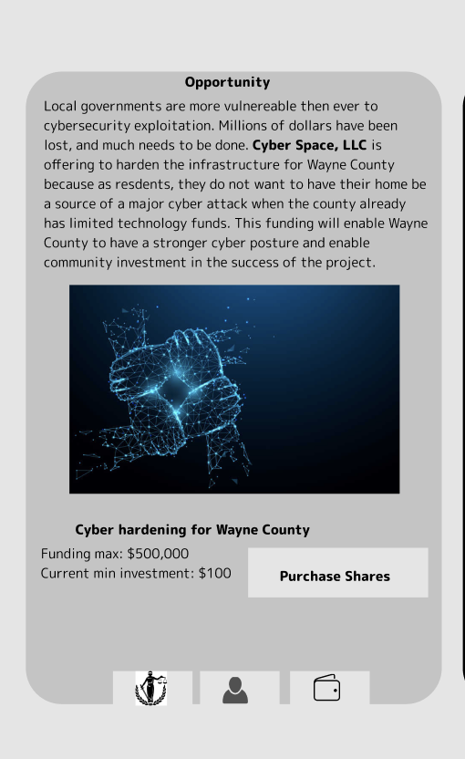

User wallet
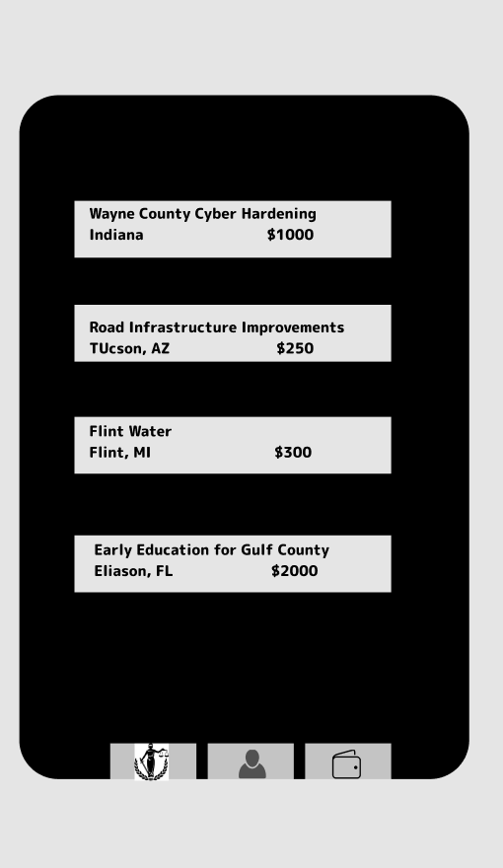

Go to Market

- Engage/Recruit Influencers - make them feel part of the product’s success and design
  - Ask for direct product feedback
  - Feedback on blog post/press release
- Invite Contributors Before Public Launch - ensure content is populated
- Blog Post - “Core Infrastructure”
  - Post on Lincoln network?
  - Submit to TechCrunch, globe newswire, Kulture Lab, yahoo finance, forbes, business insider, civic tech publications, cision
- Press Release
  - Reach out to press contacts (see above)
  - Mass distro other press (see http://customerdevlabs.com/2013/09/24/google-news-api-mturk-press/)
- Product Hunt, the Hustle, Crowdwise, SO capital

How we make money:
-% of investment/crowdfunding raised (2%)
-%equity in businesses formed out of it

Post-Launch Marketing

- Product Deconstructions Blog Posts
- *Find a partner, technical and legal

